|  |  |
| --- | --- |
| **EXP : 7** | **COOKIE TO STORE USER INFORMATION** |

**AIM:**

Write a Servlet program to  
store a user's preferences (like theme or language) using cookies. Retrieve and  
display these preferences on subsequent visits.

**CODE:**

**Cookie.html:**

<!DOCTYPE html>

<html>

<head>

<meta charset="ISO-8859-1">

<title>Cookies</title>

</head>

<body>

    <form action="/Pavithra/cookie" method = "post" >

    <p>

    <label>Username: </label>

    <input type="text" name="username">

    </p>

    <p>

    <label> Password: </label>

    <input type="password" name = "password">

    </p>

    <button type="submit"> Submit </button>

    </form>

</body>

</html>

**Cookie.java:**

package com.pavithra.servlet;

import java.io.IOException;

import javax.servlet.ServletException;

import javax.servlet.annotation.WebServlet;

import javax.servlet.http.Cookie;

import javax.servlet.http.HttpServlet;

import javax.servlet.http.HttpServletRequest;

import javax.servlet.http.HttpServletResponse;

/**

 * Servlet implementation class cookie

 */

@WebServlet("/cookie")

public class cookie extends HttpServlet {

private static final long serialVersionUID = 1L;

    /**

     * @see HttpServlet#HttpServlet()

     */

    public cookie() {

        super();

        // TODO Auto-generated constructor stub

    }

/**

* @see HttpServlet#doGet(HttpServletRequest request, HttpServletResponse response)

*/

protected void doGet(HttpServletRequest request, HttpServletResponse response) throws ServletException, IOException {

// TODO Auto-generated method stub

response.getWriter().append("Served at: ").append(request.getContextPath());

}

/**

* @see HttpServlet#doPost(HttpServletRequest request, HttpServletResponse response)

*/

protected void doPost(HttpServletRequest request, HttpServletResponse response) throws ServletException, IOException {

String user = request.getParameter("username");

String pass = request.getParameter("password");

if(user.equals("admin") && pass.equals("admin123") ){

        Cookie username = new Cookie("username", user);

        username.setMaxAge(60*60);

        username.setPath("/");

        response.addCookie(username);

        response.sendRedirect("getCookie.jsp");

}

}

}

**GetCookie.java:**

<!DOCTYPE html>

<html>

<head>

<meta charset=*"ISO-8859-1"*>

<title>Insert title here</title>

</head>

<body>

<%

  Cookie[] cookies = request.getCookies();

        String cookieName = "username";

**if** (cookies != **null**) {

**for** (Cookie cookie : cookies) {

**if** (cookieName.equals(cookie.getName())) {

System.out.println("username "+cookie.getName());

out.println(cookie.getValue());

                }

            }

        }

   %>

</body>

</html>

**OUTPUT:**

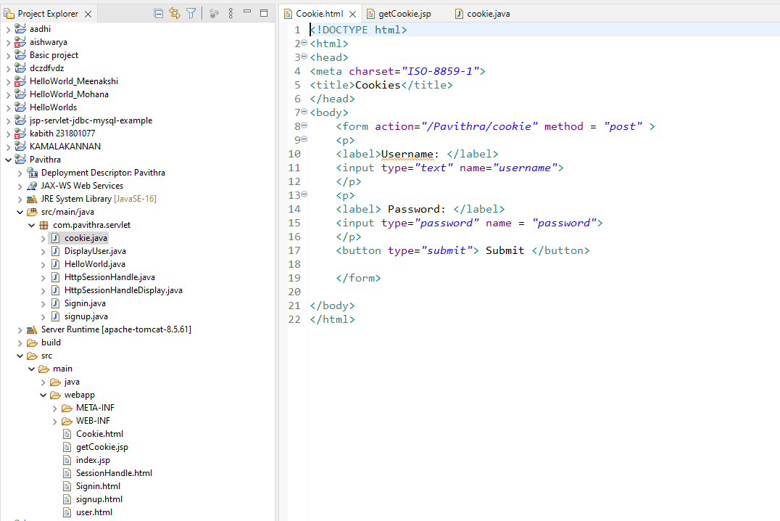

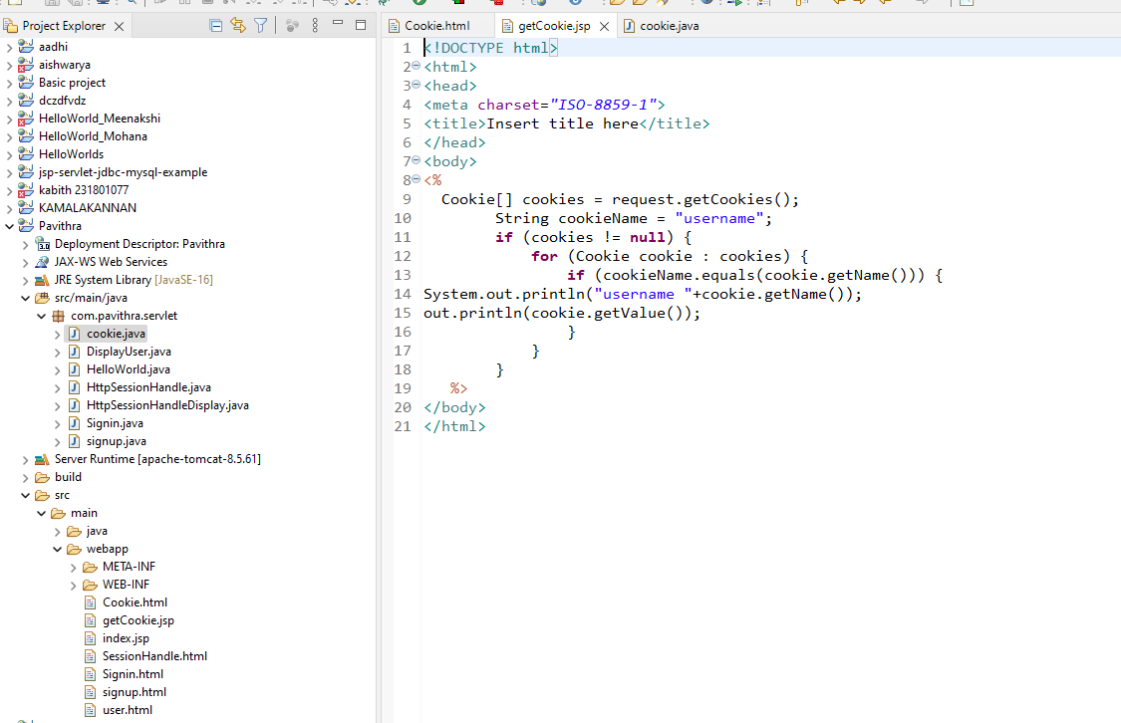

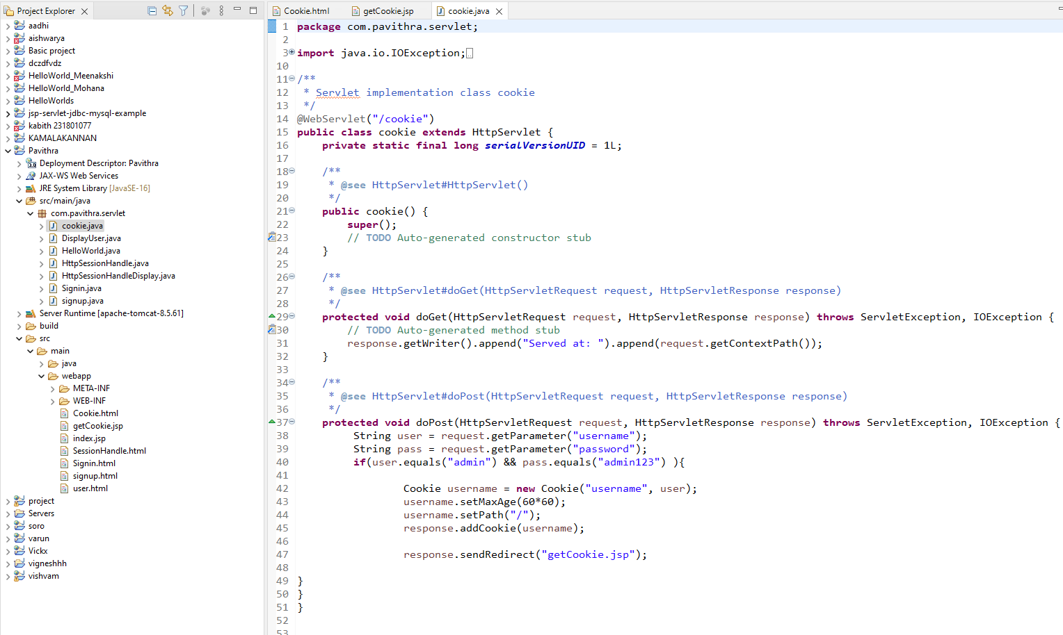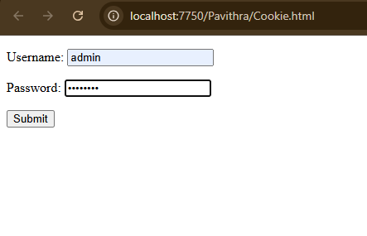

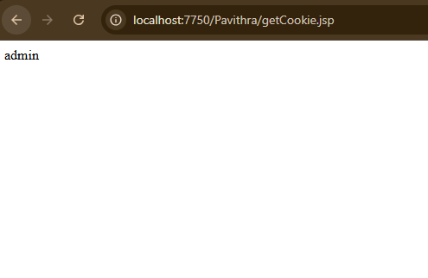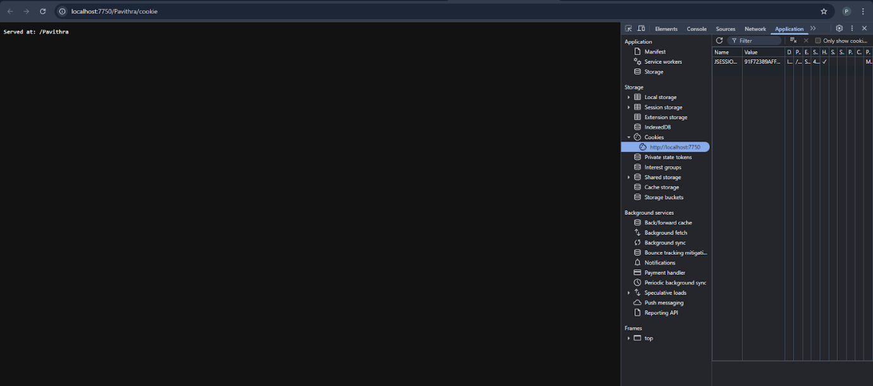

**RESULT:**

Handling user information using cookie is done using servlet successfully.